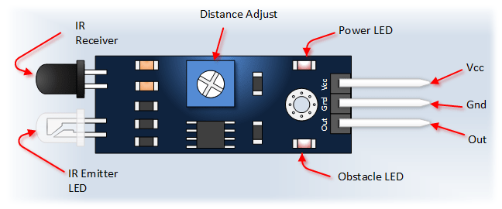

**AUTOMATIC ROOM LIGHT CONTROL**

**ABSTRACT:**

As the electricity costs rise, increasing efforts has gone into minimizing the energy consumption of electric components installations. Automatically controlling the electricity in such a way that the lighting level is always accurately matched to a actual need allows to save on energy costs. By using the system implemented here, we can intentionally forget about the lighting system as the system will automatically take care of the installations.

**INTRODUCTION:**

This Project ―Automatic Room Light Controller with Visitor Counter using Microcontroller is a reliable circuit that takes over the task of controlling the room lights as well us counting number of persons/ visitors in the room very accurately. When somebody enters into the room then the counter is incremented by one and the light in the room will be switched ON and when any one leaves the room then the counter is decremented by one. The light will be only switched OFF until all the persons in the room go out. The total number of persons inside the room is also displayed on the seven segment displays.

**COMPONENTS AND THEIR DESCRIPTION:**

1. Microcontroller 8051: The AT89S52 is a low-power, high-performance 8-bit microcontroller with 8K bytes of in-system programmable Flash memory. The device is manufactured using Atmel’s high-density nonvolatile memory technology and is compatible with the Industry-standard 80C51 instruction set and pin out.
2. Infrared Sensor Module: It has built-in transmitter and receiver circuit that detects any obstacle obstructing the path.

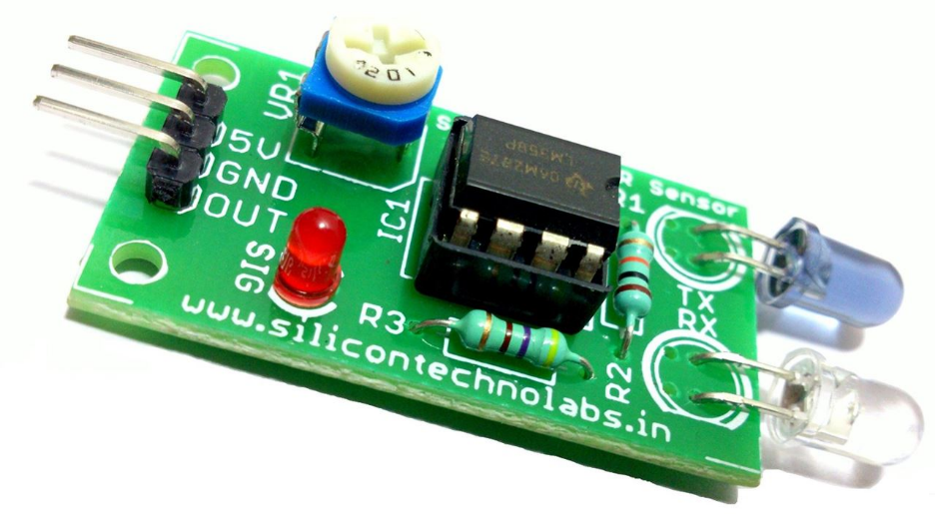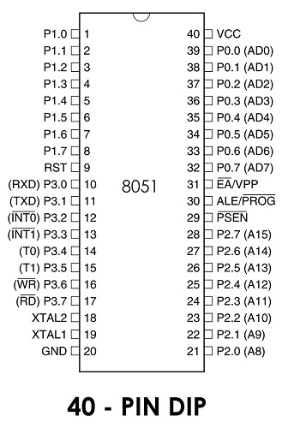

1. 16*2 lcd display

4. 8051 Development board: This board is perfect for programming 8051 microcontroller as well as for designing and testing 8051 based projects. The board has onboard AT89S52 MCU(8K Flash Memory). Board has on board power supply circuit, RS 232 port for serial communication with computer and other serial device(GPS modules, GSM Modems,RFID Reader),power status LED(RED),Reset switch, User switch, User LED(GREEN), and port extensions for all 4 ports. ISP (in-circuit programming) header port for easy programming.

5. Relay module.

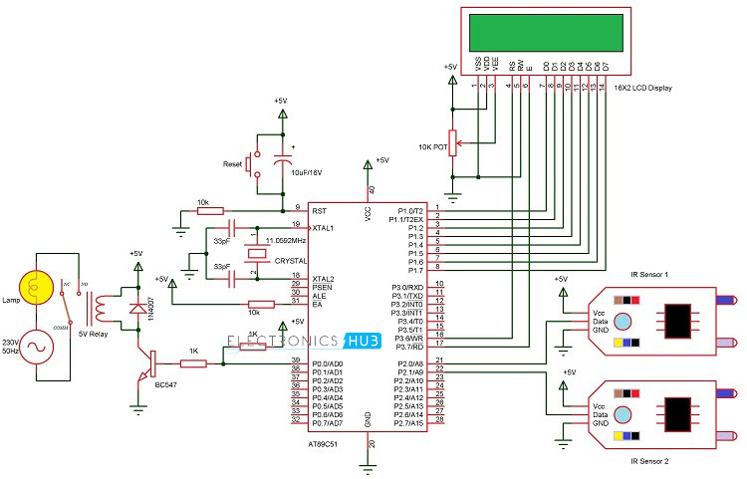

**WORKING:**

1. The two IR sensors S1 and S2 are placed on either sides of the entrance. When a person tries to enter the room S1 detects the person first and then S2. This action will indicate 8051 that the person is entering the room. Hence the lights will be turned on and the counter will be incremented accordingly.
2. Similarly when a person tries to leave the room, S2 detects the person first and then S1. This will make microcontroller to understand that a person is leaving the room and hence it decrements the counter.
3. Hence when the count is reduced to zero, the light is turned off.

**APPLICATIONS:**

* Automatic Room Lighting with Bidirectional Visitor Counter can be used to automatically turn on the light in a room when a person enters the room and turn it off when the person leaves the room.
* The project can also be dubbed as a Bidirectional Visitor Counter it is an integral part of the Automatic Room Lighting circuit.
* The project can be modified with LEDs and as the number of persons in the room increases, the number of LEDs turning ON also increases.
* It can be used to save electricity.

**SOURCE CODE**

#include<reg51.h>

#define lcd P1

sbit rs=P3^6;

sbit e=P3^7;

sbit relay=P0^0;

sbit s1=P2^0;

sbit s2=P2^1;

void delay (int);

void cmd (char);

void display (char);

void init (void);

void string (char *);

void view (int);

int count=0;

int no[10]={48,49,50,51,52,53,54,55,56,57};

void delay (int d)

{

unsigned char i=0;

for(;d>0;d--)

{

for(i=250;i>0;i--);

for(i=248;i>0;i--);

}

}

void cmd (char c)

{

lcd=c;

rs=0;

e=1;

delay(5);

e=0;

}

void display (char c)

{

lcd=c;

rs=1;

e=1;

delay(5);

e=0;

}

void string (char *p)

{

while(*p)

{

display(*p++);

}

}

void view (int n)

{

cmd(0xc0);

display(no[(n/10)%10]);

display(no[n%10]);

}

void init (void)

{

cmd(0x38);

cmd(0x0c);

cmd(0x01);

cmd(0x80);

}

void main()

{

init();

string("counter........");

cmd(0xc0);

view(count);

while(1)

{

if(s1==1)

{

while(s2==0);

if(count!=99)

count=count+1;

while(s2==1);

view(count);

}

else if(s2==1)

{

while(s1==0);

if(count!=0)

count=count-1;

while(s1==1);

view(count);

}

else if(count==1)

relay=0;

else if(count==0)

relay=1;

}

**BIBLIOGRAPHY**

1. [**www.circuitdigest.com**](http://www.circuitdigest.com)
2. [**www.electronicshun.com**](http://www.electronicshun.com)
3. **Ieee papers**
4. **Wikipedia**